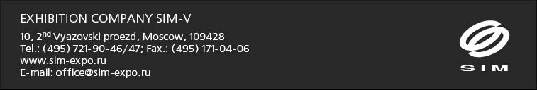

The Company " SIM-V " specializes on construction of exhibition stands since 1995. Since 2000 we actively work in the field of the outdoor advertising, design, decoration of presentations, television studios, and also furnish of interiors, offices and shops.
A long-term operational experience in the market of exhibition services, own industrial base, high professionalism of young talented experts allow to provide at present an optimum parity of quality, terms and costs of our works.
The diplomated experts in the field of design will develop for you exclusive design-project in view of all your wishes and features of your shown product.

Our company pays separate attention to industrial base, putting not only greater financial assets, but also carefully supporting professional growth and discipline of workers of manufacture, it is no secret that the mortgage of fruitful and qualitative work on a platform is clearness and coordination of mutual understanding of employees.

The young managers keen by the business who with enhanced attention concern to each separately taken client work for us. You receive their professional support at each stage of creation of the project, and the vertical control system of the company allows to react quickly to acceptance of financial or technological questions under each project.

It is necessary to note, that for more than 10-years term of the successful activity company "SIM-V" has got the most valuable and a fixed capital - trust of the clients and partners, and honorable diplomas and letters of thanks give us one more occasion for pride of the business.

We by the right are proud the clients, among which: Pantech, TEZ TOUR, KIA, Anex Tour, RusClimate, Group of the Companies of the Tic, CompTek, Fisher, Cassio, Golden Ring, the Circle, GTI, Odrex, Good food, TBI, Seiji, Acteon, Furniture the Alliance and many other things.

We shall be glad to offer our services and to see you among our clients!!!

